NGS Library Dilution and QC Analysis
  - CRI Sequencing Core Facility.
Last updated: April 21, 2026

Assessing library quality before submission is strongly recommended to ensure optimal sequencing performance and high-quality data. This guide outlines how to evaluate library size distribution and concentration, dilute to the appropriate molarity, and prepare an equimolar pool for sequencing.

Overview of Required QC
You will:
- Measure library size distribution (TapeStation or BioAnalyzer).
- Measure library concentration (Qubit).
- Calculate and perform dilution to a target molarity (10 nM recommended; 4 nM for low-concentration libraries).
- Verify concentration after dilution.
- Pool equal volumes of normalized libraries.
- Verify concentration of the final pool.
- Upload the completed QC form to PPMS.
QC Form: Download the QC form from PPMS when you place an order.

Step-by-Step Instructions
- Determine average library size.
Run each library on TapeStation (or BioAnalyzer) to confirm size distribution and estimate the average fragment size. Record the average library size in the QC form under: “TapeStation Size (bp)”.
ChIP-seq or RNA-seq libraries
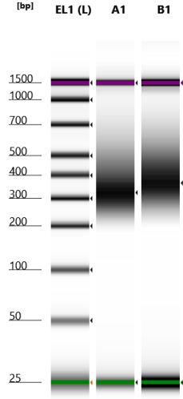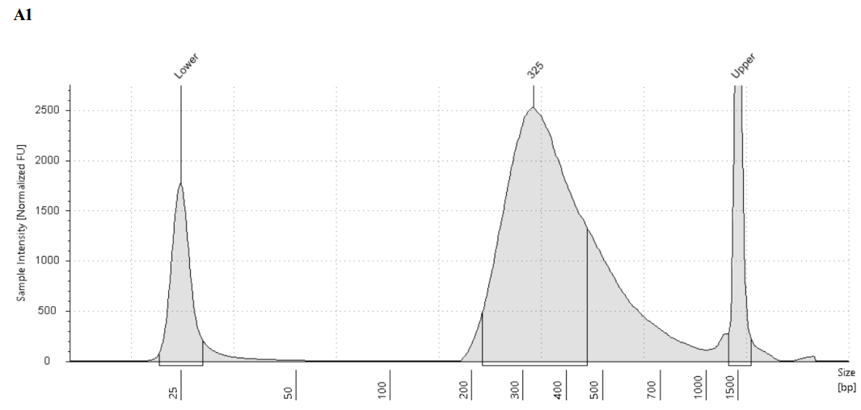
ATAC-seq libraries
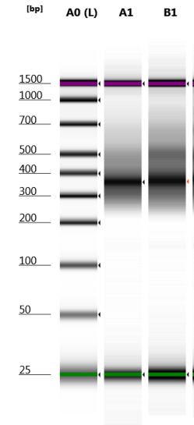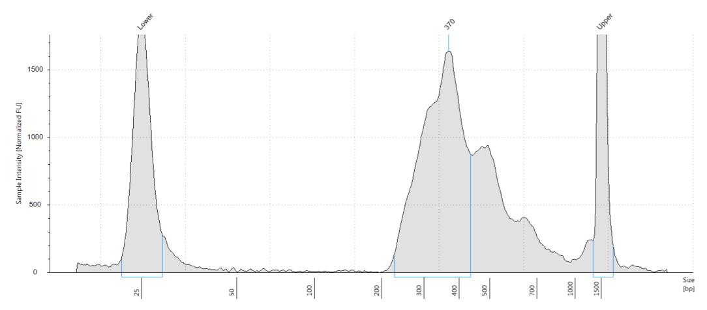
- Quantify each library.
Measure the concentration of each library using Qubit (dsDNA HS assay recommended). Record the concentration in the QC form under: “Qubit Conc. (ng/µL)”. The QC form will automatically calculate the corresponding molar concentration (nM) based on the library size.
- Dilute each library to the target molarity.
Using the calculations provided in the QC form, dilute each library to: 10 nM (recommended), or 4 nM (for low-concentration libraries). The QC form will automatically generate the dilution instructions.
- Verify the concentration of the diluted library. Measure the concentration of the diluted library using Qubit and record the result in the QC form. The measured concentration should be close to the target (typically within ±10%). If the measured concentration is substantially higher or lower than expected, repeat Steps 2–3 to ensure accurate quantification and dilution.
- Pool normalized libraries.
Combine the diluted libraries into a single tube by pipetting 5 µL of each diluted library into the pool. This creates an equal-volume pool from normalized libraries (assuming each library has been successfully diluted to the same target molarity).
- Quantify the pooled library.
Measure the concentration of the pooled library using Qubit. The pooled concentration should be close to your target (10 nM or 4 nM, depending on what you used). Record the pooled concentration in the QC form.
- Submit QC documentation.
Complete the QC form and upload it to the PPMS ordering page with your submission.

Need Help?
If you have any questions or encounter issues during QC or dilution, please contact:
- Sequencing Core Manager: Dr. Yoon Jung Kim, YoonJung.Kim@UTSouthwestern.edu
- Sequencing Core Director: Dr. Sihan Wu, Sihan.Wu@UTSouthwestern.edu

Instrument Access
The CRI Sequencing Core Facility provides no-cost access to the following instruments for clients:

- Agilent TapeStation 4150
- Qubit 3 Fluorometer
- To use other instruments, including 10X Genomics Chromium X, Covaris ME220, and BioRad CFX384, please visit NL12.110C.
Clients must bring their own reagents and consumables for library QC prior to sample submission.

Reagents and Consumables (Catalog Numbers)
TapeStation 4150
- Agilent D1000 ScreenTape: 5067-5582
- Agilent D1000 Reagents (includes ladder and sample buffer): 5067-5583
Qubit 3
- Invitrogen Qubit dsDNA HS Assay Kit: Q32851 or Q32854
- Invitrogen Qubit Assay Tubes: Q32856

